Luminaries of the College
The literary meaning of Luminary is a person who inspires or influences others, especially one prominent in a particular sphere. Sakshi Malik Govt. college for Girls, Mokhra is blessed to have located in such a region that has remained politically and socially very active since historical times.
There are many personalities having their profound impact on girl students. Many poets, writers, politicians and film stars belong to this region and have an inspirational impact on the minds of students. Among these Luminaries present one of the very famous wrestler Sakshi Malik is the most inspiring personality for our students.
Sr. No | Name of Luminaries | Photo | Brief Intro and Noted Achievements
1 | Sakshi Malik | 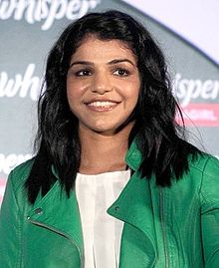 | - Sakshi Malik was born on 3 September 1992 in Mokhra village[15] of Haryana's Rohtak district to Sukhbir, a bus conductor with Delhi Transport Corporation, and Sudesh Malik, a supervisor at a local health clinic. According to her father, she was motivated to take up wrestling from seeing her grandfather Badlu Ram, who was also a wrestler. She began training in wrestling at the age of 12 under a coach, Ishwar Dahiya, at an Akhara in Chhotu Ram Stadium, Rohtak.  - She has won had previously won the silver medal at the 2014 Commonwealth Games in Glasgow, and the bronze medal at the 2015 Asian Wrestling Championships in Doha.  - She won the bronze medal in her event at the 2022 Tunis Ranking Series event held in Tunis, Tunisia. She then went on to win the gold medal at 2022 Birmingham Commonwealth Games.

