NSS
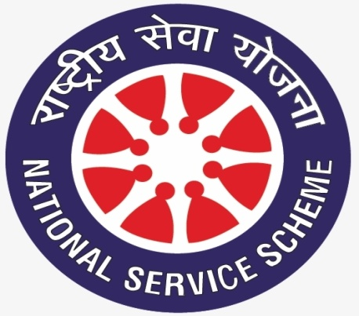
Introduction
National Service Scheme (NSS) was introduced in 1969 with the primary objective of developing the personality and character of the student youth through voluntary community service. ‘Education through Service’ is the purpose of the NSS. The ideological orientation of the NSS is inspired by the ideals of Mahatma Gandhi. An NSS volunteer places the ‘community’ before ‘self’.
Objectives of NSS:
NSS aims at developing the following qualities/ competencies among the volunteers:
a) To understand the community in which the NSS volunteers work and to understand themselves in relation to their community;
b) To identify the needs and problems of the community and involve themselves in problem-solving exercise;
c) To develop among themselves a sense of social and civic responsibility;
d) To utilize their knowledge in finding practical solutions to individual and community problems;
e) To gain skills in mobilizing community participation;
f) To acquire leadership qualities and democratic values;
g) To develop capacity to meet emergencies and natural disasters; and
h) To practice national integration and social harmony.

NSS attempts to establish meaningful linkages between ‘Campus and Community’, ‘College and Village’ and ‘Knowledge and Action’
Motto:
The motto of National Service Scheme is NOT ME BUT YOU
Benefits of Being a NSS Volunteer:
A NSS volunteer who takes part in the community service programme would either be a college level or a senior secondary level student. Being an active member these student volunteers would have the exposure and experience to be the following:
a) an accomplished social leader
b) an efficient administrator
c) a person who understands human nature
Major Activities:
National Integration Camp (NIC):
The National Integration Camp (NIC) is organized every year and the duration of each camp is of 7 days with day-night boarding & lodging. These camps are held in different parts of the country. Each camp involves 200 NSS volunteers to undertake the scheduled activities.
Objectives of the National Integration Camp
Make the NSS volunteers aware of the following:
a) Rich cultural diversity of India
b) History of our diversified culture
c) National pride through knowledge about India
d) To integrate the nation through social service
Adventure Program:
The camps are held every year which are attended by approximately 1500 NSS volunteers with at least 50% of the volunteers being girl students. These camps are conducted in Himalayan Region in the North and Arunachal Pradesh in North East region. The adventure activities undertaken in these camps includes trekking of mountains, water rafting, Para-sailing and basic skiing.
Objectives of Adventure Program
a) Promote various adventure activities among NSS volunteers
b) Infuse the sense of love towards the various regions of India
c) Enhance leadership qualities, fraternity, team spirit and risk taking capacity.
d) Improvement of physical and mental strength
e) Exposure to new vocational possibilities
NSS Republic Day Parade Camp:
The first Republic Day Camp of NSS Volunteers was held in 1988. The camp takes place in Delhi between 1st and 31st January every year with 200 NSS selected volunteers who are good in discipline, March-past and cultural activities.
A Contingent of selected NSS volunteers participates in the Republic Day Parade at Rajpath, New Delhi on 26th of January every year in accordance with the guidelines and requisition of the Ministry of Defence.
Objectives of NSS Republic Day Parade Camp
a) Enable the volunteers to interact with fellow members hailing from various parts of India.
b) Experience the tradition, custom, culture, language of all states of India.
c) Provide a chance to develop overall personality of the Student volunteers.
d) Constitute the bond of patriotism, national integration, brotherhood and communal harmony.
National Youth Festivals
National Youth Festivals are organized every year from 12th to 16th January by the Government of India, Ministry of Youth Affairs & Sports in collaboration with the State Governments in different parts of the country. Eminent guests, speakers and youth icons are invited to address and interact with about 1500 participating NSS volunteers during the National Youth Festivals.
Objectives of National Youth Festivals
a) Make the volunteers aware of the various festivals celebrated in the country
b) Remind the volunteers of the cultural importance of festivals celebrated in our country
c) Provide a chance to the NSS volunteers to interact with the resource person/speaker/youth icons
National Service Scheme Award
The Ministry of Youth Affairs and Sports, Government of India had instituted the National Service Scheme Awards to recognize the voluntary service rendered by NSS volunteers, Programme Officers, N.S.S. units and the university/senior secondary council.
NSS in Sakshi Malik Government College for Girls, Mokhra
There is one unit of NSS in the college which is led by the programme officer appointed by the Principal. Volunteers have to register themselves in July month each year. To uphold and promote the values of communal harmony, patriotism, and national integration among students and community members through NSS activities is one of the basic objectives of the unit. The NSS unit will be involved in awareness programme related to HIV/AIDS prevention, plantation, cleanliness and blood donation etc. A merit certificate is awarded by the affiliated university to the volunteers after successfully completing two years in NSS.
Conditions for NSS certificate:
Although the conditions for awarding a NSS merit certificate changing time to time but some basic conditions are as follows:
a) Minimum Two years as NSS volunteer.
b) Total 240 hours of social service, 120 hours each year.
c) Two one day camp every year.
d) At least One Seven Days Special camp as NSS Volunteer.
e) Two time Blood Donations or Literate at least five persons in the society.

