College Faculty Members
Sr. No | Name of the Faculty Member | Photo
Dr. Poonam Aghi, Associate Professor, Economics
Ph.D, M.Phil
E-Mail: Poonam.aghi1967@gmail.com
Contact No: 9896363404
2. | Mrs. Sunita Dhankhar, Assistant Professor, Political Science  M.Phil, UGC NET  E-Mail: Dhankharsunita931@gmail.com  Contact No: 7988252441 | 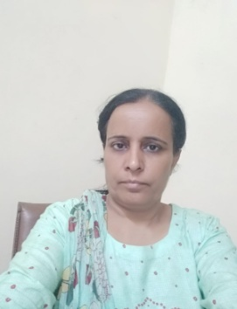
3. | Mrs. Rachna Devi, Assistant Professor, Mathematic  M.Sc, CSIR-UGC NET-JRF, M.Phil  E-Mail: rachnagoyet@gmail.com  Contact No: 8222822449 | 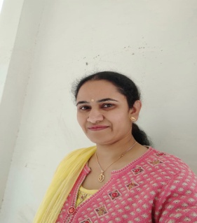
4. | Ms. Kavita Anand, Assistant Professor, Commerce  M.Com, M.Phil, UGC NET-JRF  E-Mail: Kavitaanand44@gmail.com  Contact No: 9253120138 | 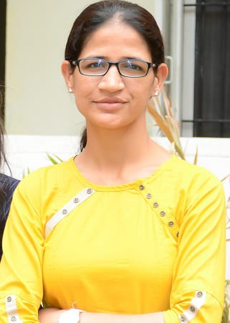
5. | Sh. Ishwar Singh, Assistant Professor, History  MA, UGC NET  E-Mail: ishwarsinghckd@gmail.com  Contact No: 9050420643
6. | Mrs. Sonia, Assistant Professor, History  MA, M.Phil, UGC NET-JRF  E-Mail: Soniaahlawat084@gmail.com  Contact No: 8901353818
7. | Dr. Mahak, Assistant Professor, Economics  Ph.D, M.Phil, UGC NET, JRF  E-Mail : meenuverma1127@gmail.com  Contact No: 9468146660 | 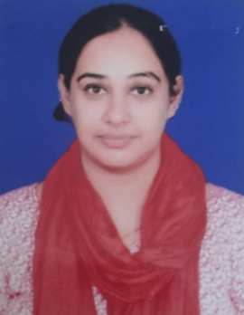
8. | Sh. Sandeep Kumar, Assistant Professor, Hindi  MA, UGC NET  E-mail: sandeepkumarmadina@gmail.com  Contact No.: 9015715311 | 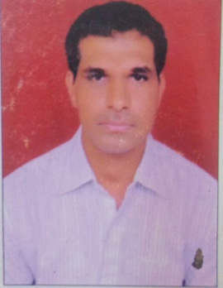
9. | Dr. Vinod Kumar, Assistant Professor, Geography  Ph.D, M.Phil, UGC NET, JRF  E-Mail vinodkumar7262@gmail.com  Contact No: 9992242992 | 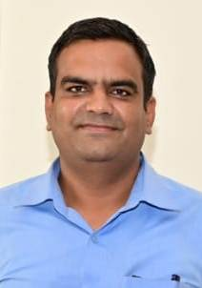

College Non-Teaching Staff Members
Sr. No. | Name and Designation | Photo
01 | Sh. Rupesh Kumar  Deputy-Superintendent,  Contact No: 9416977968  E-Mail: sahilkhera06@gmail.com | 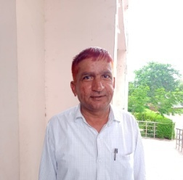
02 | Sh. Sandeep Kumar  Assistant  Contact No: 8059514735  E-Mail: sandyduggal6@gmail.com
03 | Sh. Ramesh Kumar  J.L.A.  Contact No. 9896038942  E-Mail:-
04 | Sh. Suresh Kumar  Lab Attendant  Contact No. 9050716430  E-Mail:- | 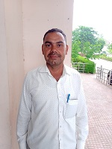
05 | Mrs. Prabha  Steno-Typist  Contact No. 7988317872  E-Mail:-
06 | Sh. Parmjeet  Clerk  Contact No: 7206384788  E-Mail: malikboy.malik8@gmail.com | 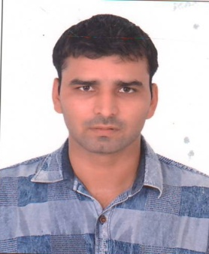
07 | Sh. Ashisk Malik  Lab Attendant  Contact No: 9992435560  E-Mail: Ashishmalik12499@gmail.com | 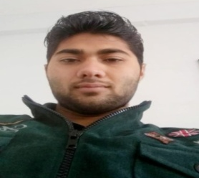
08 | Sh. Parveen Kumar  Peon  Contact No: 9253143305  E-Mail: kumarpraveen2193@gmail.com | 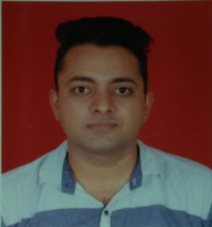

College Computer Lab Staff
01 | Sh. Krishan Yadav, Computer Instructor  M. Tech (Computer Science & Engineering)  Contact No: 8607466603, 8307702863  E-Mail: ksycomp@gmail.com | 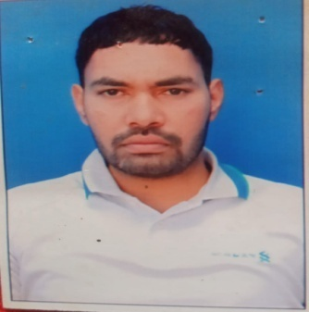
02 | Sh. Ravinder, Computer Attendant  B.Tech (Computer Science & Engineering)  Contact No: 9416383008  E-Mail: citusharma@gmail.com | 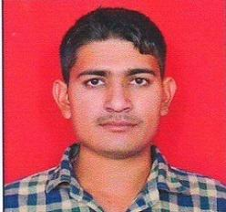

Employees posted under Haryana Kaushal Rojgar Nigam (HKRN)
Sr. No | Name and Designation | Photo
01 | Sh. Deepak,  Chowkidar  Contact No: 8398097051
02 | Sh. Parmod  Chowkidar  Contact No: 9671905068 | 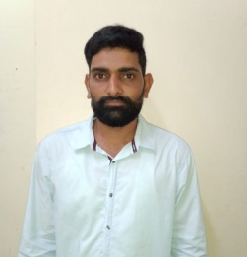
03 | Sh. Mannu  Mali  Contact No: 7419283179
04 | Smt. Munni Devi  Sweeper  Contact No: 9992488038

